The Parish Church of St Andrew
Orford with Longford

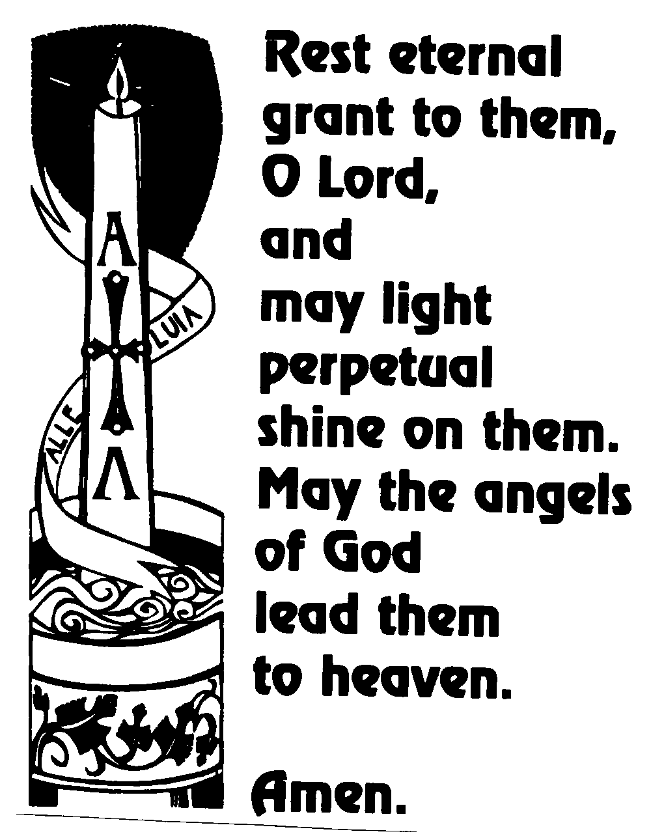

Linda Leicester
1948 - 2008

Wednesday 11th June 2008

Order of Service

When all have gathered around the grave:

Introduction

Priest: “Jesus said, ‘I am the resurrection and I am the life; they who believe in me, though they die, yet shall they live, and whoever lives and believes in me shall never die.’” (John 11. 25, 26)

We meet in the name of Jesus Christ, who died and was raised to the glory of God the Father. Grace and mercy be with you. Amen.

The priest introduces the service

Priest: Let us pray:

Almighty God, you judge us with infinite mercy and justice, and love everything you have made. In your mercy turn the darkness of death into the dawn of new life, and the sorrow of parting into the joy of heaven; through our Saviour, Jesus Christ. Amen

All: Merciful Father, hear our prayers and comfort us; renew our trust in your Son, whom you raised from the dead; strengthen our faith that all who have died in the love of Christ will share in his resurrection; who lives and reigns with you, in the unity of the Holy Spirit, one God, now and for ever. Amen

The Reading 1 Peter 1. 3-9

Praise be to the God and Father of our Lord Jesus Christ! In his great mercy he has given us new birth into a living hope through the resurrection of Jesus Christ from the dead, and into an inheritance that can never perish, spoil or fade – kept in heaven for you, who through faith are shielded by God’s power until the coming of the salvation that is ready to be revealed at the end of time.

In this you greatly rejoice, though now for a little while you have had to suffer grief in all kinds of trials. These have come so that your faith - of greater worth than gold, which perishes even though refined by fire – may be proved genuine and may result in praise, glory and honour when Jesus Christ is revealed.

Though you have not seen him, you love him, and even though you do not see him now, you believe in him and are filled with an inexpressible and glorious joy, for you are receiving the goal of your faith, the salvation of your souls.

This is the word of the Lord
Thanks be to God

The Address

The Prayers:

Priest: God of mercy, Lord of life, you have made us in your image to reflect your truth and light: we give you thanks for Linda, for the grace and mercy she received from you, for all that was good in her life, and especially for the memories we treasure today.

Lord, in your mercy
All: hear our prayer.

Priest: You promised eternal life to those who believe. Remember for good this your daughter Linda as we also remember her. Bring all who rest in Christ, including Thomas and those we bring to mind this morning, into the fullness of your kingdom where sins have been forgiven and death is no more.

Lord, in your mercy
All: hear our prayer.

Priest: Your mighty power brings joy out of grief and life out of death. Look in mercy on Tom, Wendy and Sarah, their families and all who mourn at this time. Give them patient faith in times of darkness. Strengthen them with the knowledge of your love.

Lord, in your mercy
All: hear our prayer.

Priest: Father, you are tender towards your children and your mercy is over all your works. Heal the memories of hurt and failure. Give us the wisdom and grace to use aright the time that is left to us here on earth, to turn to Christ and follow in his steps in the way that leads to everlasting life.

Lord, in your mercy
All: hear our prayer.

All: God of mercy, entrusting into your hands all that you have made and rejoicing in our communion with all your faithful people, we make our prayers through Jesus Christ our Saviour. Amen.
Priest: Let us pray with confidence as our Saviour has taught us
All: Our Father, who art in heaven, hallowed be thy name; thy kingdom come; thy will be done; on earth as it is in heaven. Give us this day our daily bread. And forgive us our trespasses, as we forgive those who trespass against us. And lead us not into temptation; but deliver us from evil. For thine is the kingdom, the power and the glory, for ever and ever. Amen.

Commendation and Farewell

Priest: Let us commend Linda to the mercy of God our Maker and Redeemer.

Priest: God our creator and redeemer, by your power Christ conquered death and entered into glory. Confident of his victory and claiming his promises, we entrust Linda to your mercy in the name of Jesus our Lord, who died and is alive and reigns with you, now and for ever. Amen

The Committal: We have entrusted our sister Linda to God's mercy, and we now commit her body to be cremated: in sure and certain hope of the resurrection to eternal life through our Lord Jesus Christ, who died, was buried, and rose again for us. To him be glory for ever. Amen

A prayer for Linda’ family and friends: Almighty God, Father of all mercies and giver of all comfort: deal graciously, we pray, with those who mourn, that casting all their care on you, they may know the consolation of your love; through Jesus Christ our Lord. Amen

The Blessing: May God give you his comfort and his peace, his light and his joy, in this world and the next; and the blessing of God almighty, the Father, the Son, and the Holy Spirit, be among you and remain with you always. Amen


Acknowledgement: Common Worship: Pastoral Services, material from which is included in this service, is copyright © The Archbishops’ Council (2000-2002)

